WEEK 4

Aim:
To develop a dynamic webpage using HTML, CSS, and JavaScript with login validation and dynamic display of greeting and login time.

Description:
This experiment demonstrates the use of JavaScript to add dynamic functionality to a webpage. A login page is created with username and password validation. On successful login, the user is redirected to a placement dashboard. The dashboard dynamically displays a greeting according to the current time and the login time.

Program:
Dynamic Webpage Using JavaScript

Program Code:

1.Login Page:
<html>
<head>
<title>Login-Page</title>
<meta name="viewport" content="width=device-width">
<meta charset="UTF-8">
<style>
body{
background-color: aliceblue;
background-image: url("./bgimage.jpg");
}
.heading{
text-decoration: solid;
color:white;
text-align: center;
padding-top: 20px;
}
.container{
margin-left: auto;
margin-right: auto;
height: 300px;
width: 300px;
background-color: lightsteelblue;
box-shadow: 10px 10px 20px grey;
border-radius: 20px;
align-self: center;
display: flex;
flex-direction: column;
margin-top: 80px;

}
.container h3{
align-self: center;

}
input{
display: block;
margin-left: 10%;
margin-right: 10%;
height: 30px;
}
#btn{
background-color: blue;
position: relative;
width:80%;
align-self: center;
margin-top: px;
color: white;
height: 30px;

}
label{
margin-top: 20px;
color: blue;
margin-left: 10%;
margin-right: 10%;
}
#error{
color: crimson;

align-self: center;

}
</style>
</head>
<body>
<h1 class="heading">ANITS - Central Placement Portal</h1>
<div class="container">
<h3>User Login</h3>
<label>Username</label>
<input type="text" id="name1" placeholder="Enter your username">
<label>Password</label>
<input type="password" id="password" placeholder="Enter your Password">
<p id="error"></p>
<button onclick="loginValidity()" id="btn">Login</button>

</div>
<script>
function loginValidity(){
let uname=document.getElementById("name1").value.trim();
let password=document.getElementById("password").value.trim();
let defaultUname="Lasya";
let defaultPassword="las@2206";
let error=document.getElementById("error");
error.innerHTML="";
if(uname==""){
error.innerHTML="*UserName is required";
return;
}
if(password==""){
error.innerHTML="*Password is required";
return;
}
if(uname==defaultUname && password==defaultPassword){
window.location.href="success.html";
}
else{
error.innerHTML="<b>Invalid UserName or Password.</b>";
}
}
</script>
</body>
</html

2. Success Page:
<html>
<head>
<title>Success-Page</title>
<meta name="viewport" content="width=device-width">
<meta charset="UTF-8">
<style>

body{
background-color: aliceblue;
background-image: url("./bgimage.jpg");
}
.heading{
height: 180px;
display: flex;
align-items: center;

}
.heading img{
height: 100px;
width: 100px;
margin-left: 20px;

}
.text{
flex:1;
display: flex;
align-items: center;
justify-content: center;
flex-direction: column;
color: azure;

}
.navbar{
margin-top: 0px;
height: 50px;
display: flex;
flex-direction: row;
justify-content: space-around;
background-color: purple;
}
a{
color: white;
text-decoration: none;
margin-top: 10px;
}
.box{
margin-top: 50px;
height:500px;
width: 600px;
margin-left: auto;
margin-right: auto;
background-color: lightblue;
box-shadow: 10px 10px 10px grey;
display: flex;
flex-direction: column;
justify-content: space-around;
}
.inner{
background-color: aliceblue;
border-left: 5px solid yellow;
margin-left: auto;
margin-right: auto;
width: 90%;
align-self: center;

}
li{
margin-left: auto;
margin-right: auto;
color: blue;
margin-left: 8px;
}
#greeting{
color: blue;
margin-left: 10px;
}
#loginTime{
color: blue;
margin-left: 10px;
}
.f1{
background-color: purple;
height: 50px;
display: flex;
align-items: center;
justify-content: center;
margin-top: 50px;
}
.f1 p{
color: white;

}
</style>
</head>
<header>
<div class="heading">
<img src="Logo.jpeg" alt="Logo">
<div class="text">
<h1>Anil Neerukonda Institute of Technology & Sciences</h1>
<h2>Campus Placement Portal</h2>
</div>
</div>
</header>
<div class="navbar">
<a href="#">Home</a>
<a href="#">About</a>
<a href="#">Apply Job</a>
<a href="#">UpComing Placements</a>
<a href="#">Contact</a>
</div>

<body>
<div class="box">
<h2 style="color: green; margin-left: 10px;">Login Successfull!</h2>
<p style="color: darkblue;margin-left: 10px;">Welcome to ANITS Central Placement Portal</p>
<p id="loginTime"></p>
<p id="greeting"></p>
<div class="inner">
<h2 style="color: blue; margin-left: 5px;">Important Notice</h2>
<ul>
<li>Please contact the <b>Training & Placement Office</b> regularly for updates.</li>
<li>Stay informed about the latest <b>MAANG Companies Recruitment Process.</b></li>
<li>Check your registered Email ID and Placement Portal for Announcements.</li>
<li>Attend all Pre-Placement Talks (PPTs),Aptitutde Training,Mock Interviews and Campus Drives</li>
<li>Keep your Resume,Academic Documents, and ID Card ready before every Recruitment process.</li>
</ul>
</div>
</div>
<footer class="f1">
<p>&copy 2026 ANITS | Department of Training and Placement</p>

</footer>
<script>

let now=new Date();
let hours=now.getHours();
let greet="";
if(hours<12){
greet="Good Morning!";
}
else if(hours<17){
greet="Good Afternoon!";
}
else if(hours<21){
greet="Good Evening!";
}
else{
greet="Good Night!"
}
document.getElementById("greeting").innerHTML=greet;
document.getElementById("loginTime").innerHTML="Login Time :"+now.toLocaleTimeString();

</script>
</body>
</html>

Details About Program:
Saved in: Week 4 folder of the repository.
Files used: Login page and Success Dashboard page.
Technologies used: HTML, CSS and JavaScript.
Execution: The login HTML file is opened in a web browser.
Working: The user enters the username and password. JavaScript validates the details. On successful login, the success dashboard is displayed with the current login time and an appropriate greeting.

Output:

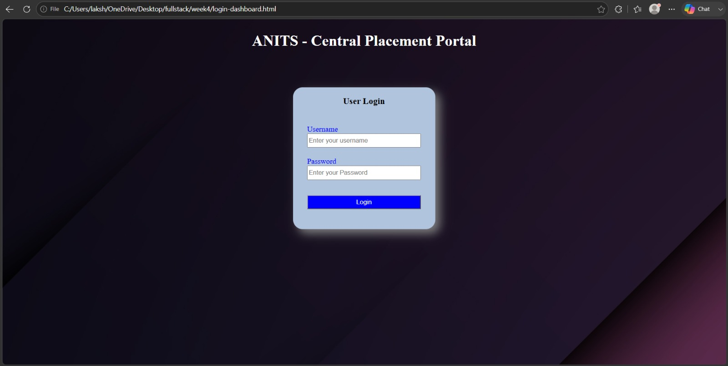

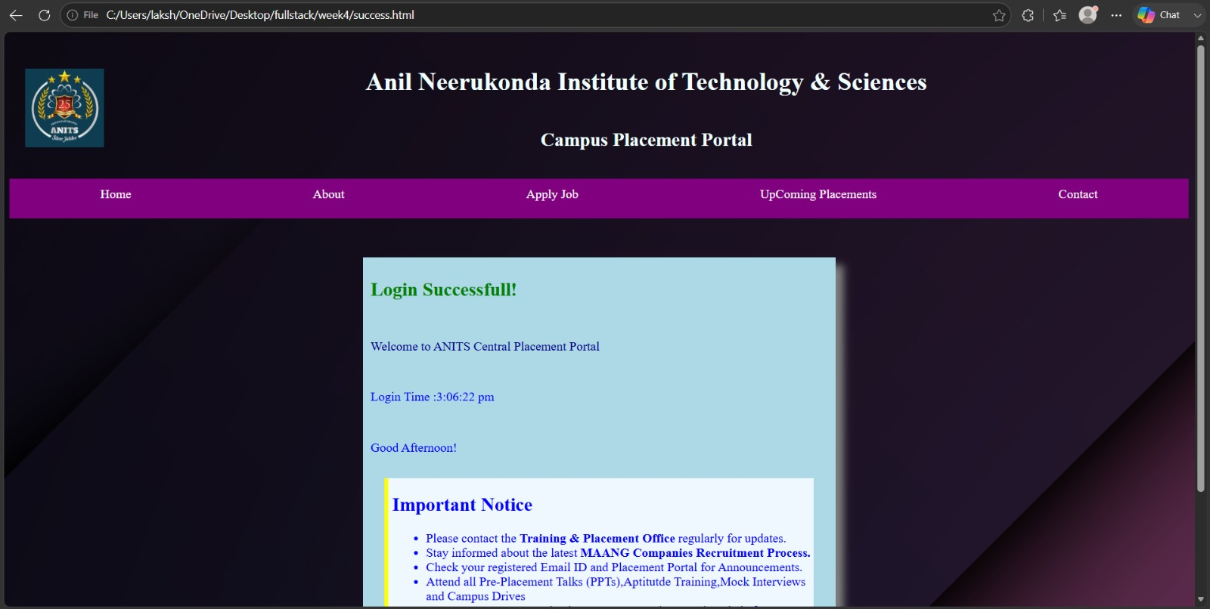

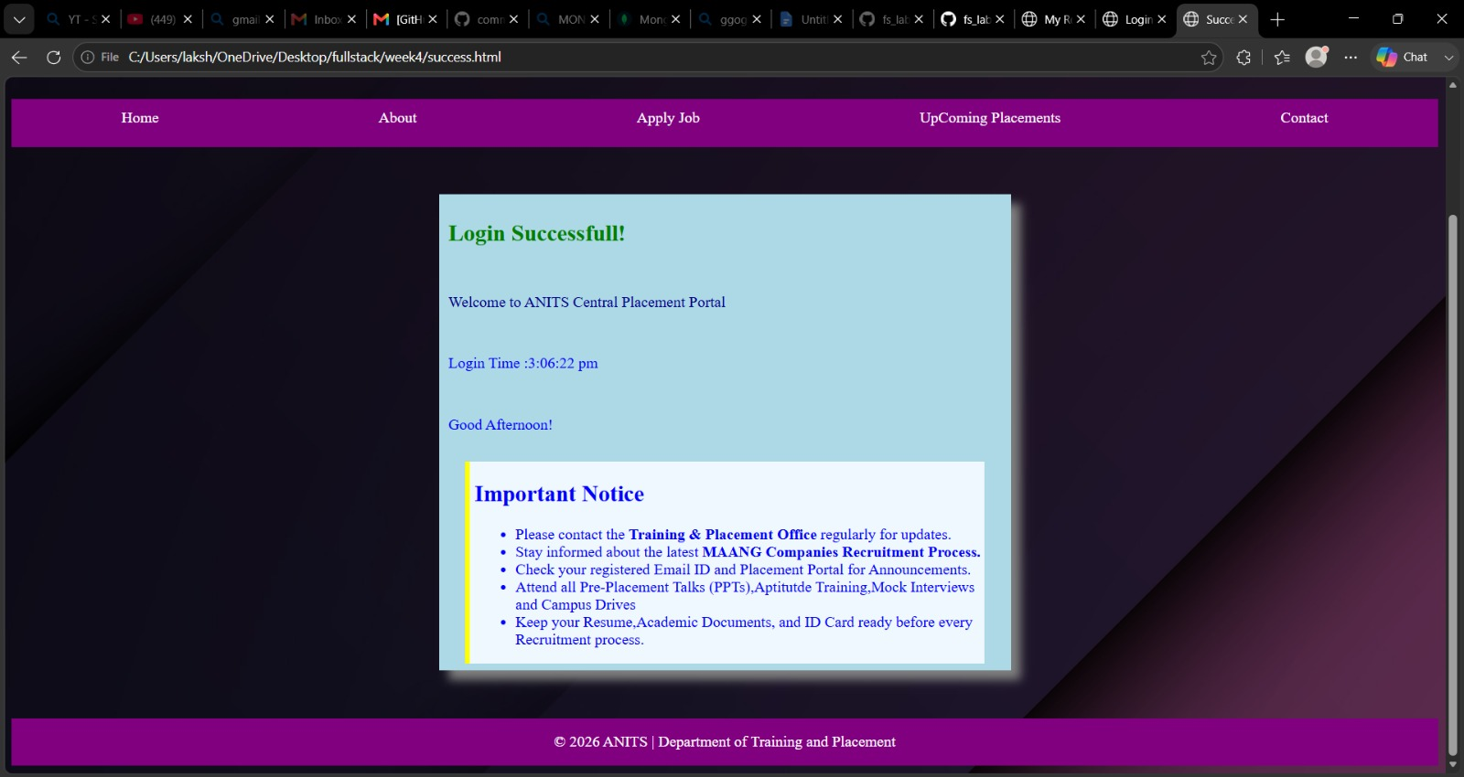

Result:
The dynamic webpage was successfully developed using HTML, CSS and JavaScript with login validation, dynamic greeting and login time.

